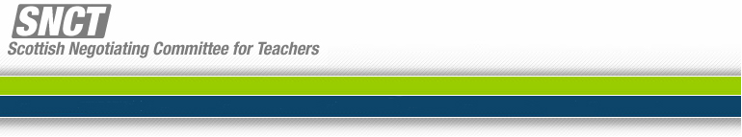
JS/11/25
14 June 2011

Dear Colleague

Teacher Induction Scheme

The SNCT has agreed that the class contact time of probationer teachers on the Teacher Induction Scheme will be increased from a maximum of 15.75 hours to a maximum of 18.5 hours per week. This equates to an increase to 0.82 FTE. Changes to the SNCT Handbook of Conditions of Service for teachers have been made accordingly.

You will be aware that the GTCS has raised some concerns about increasing beyond 0.8FTE and has suggested some flexibility in implementation of the new working arrangements for probationer teachers. The Joint Chairs and Joint Secretaries have considered the terms of the letter sent by Anthony Finn, Chief Executive, GTCS, to Directors of Education which is appended. The Joint Secretaries have also met with GTCS to consider the matter directly. This meeting was constructive and positive.

The SNCT, recognising that GTCS has responsibility for professional standards, accepts that there is scope for flexibility in local decision making around how class contact time might be balanced over the course of the year for probationer teachers. We would ask that local authorities take into account the GTCS request for flexibility in the implementation of the new arrangements for probationer teachers who commence deployment in August 2011.

The SNCT also advises that in the few cases where probationer teachers require additional support to achieve the Standard for Full Registration it would not be appropriate to increase the maximum class contact time at a later stage in the session.

Yours sincerely

Tom Young (Employer’s Side)
Drew Morrice (Teachers’ Panel)
Stephanie Walsh (Scottish Government)

Joint Secretaries

