LNCT
Aberdeenshire Local Negotiating Committee for Teachers

Date: Aug. 2023

LNCT/23/02

PRD

This agreement has been subject to review in 2023 by the LNCT Joint Secretaries and HR as part of a review of current Aberdeenshire LNCT Agreements.

LNCT Joint Secretaries

Margaret Mackay (Education & Children’s Services) Margaret.MacKay@aberdeenshire.gov.uk

David Smith (LNCT Teachers’ Panel)
David.A.Smith@aberdeenshire.gov.uk aberdeenshire@eis.org.uk

PROFESSIONAL REVIEW AND DEVELOPMENT
CONTENTS PAGE

- INTRODUCTION | Page 2
- PRINCIPLES | Page 4
- SCHEME FOR PROFESSIONAL REVIEW AND DEVELOPMENT | Page 6
- MANAGING THE PRD PROCESS | Page 9
- STAGES IN THE PRD PROCESS | Page 10
- MONITORING AND EVALUATING THE PROCESS | Page 14
- LNCT MONITORING | Page 14

PROFESSIONAL REVIEW AND DEVELOPMENT
1. INTRODUCTION
1.1 Professional learning is what teachers engage in to stimulate their thinking and professional knowledge and to ensure that their practice is critically informed and up to date. By undertaking a wide range of high-quality, sustained career long professional learning (CLPL) experiences, teachers are more likely to inspire pupils and provide high quality teaching and learning experiences, enabling learners to attain and achieve their best. In Aberdeenshire, we aim to ensure that professional learning provides rich opportunities for teachers to develop and enhance their professional knowledge and practice, to support continuous improvement in schools.
1.2 Engagement in Professional Update is a requirement for registration with GTCS and will impact on all those who are currently registered with the General Teaching Council Scotland. Professional Update is an ongoing process, which includes the following elements:
- An annual update of your details held on the register by GTCS including checking your personal and employment details are up to date.
- Engagement in ongoing professional learning.
- Self-evaluation against the appropriate GTCS Professional Standard(s).
- Discussion of this engagement, and the impact of this, as part of the Professional Review and Development (PRD) process.
- Maintenance of a professional learning record, supported by reflective comments and/or appropriate evidence which briefly capture impact.
- 5 yearly confirmations of this ongoing engagement to GTCS (Professional Update sign-off process).

At the heart of Professional Update is the PRD process. PRD is both an entitlement and a contractual obligation. It should be an ongoing process and there should be regular opportunities to discuss professional learning. The formal PRD meeting provides a valuable opportunity for a focused professional dialogue between reviewee and reviewer.
1.3 PRD is the process of identification of CLPL and development for all staff registered with GTCS in relation to their current practice. In addition, the requirements of the establishment and local authority improvement plan, the wider and longer-term needs of the education service and national priorities should also be considered. It also provides an opportunity for discussion of a reviewee’s career aspirations and personal development needs emanating from their own self-evaluation against the appropriate GTCS Professional Standards.
1.4 PRD is one of a range of quality improvement strategies used in establishments. As such, it is central to raising attainment and achievement and leading improvements in learning and teaching. It assists teachers to professionally reflect on their practice through a process of self-evaluation and consider how they can improve their professional knowledge and understanding. Linked to CLPL, it should result in enhanced job satisfaction and improved professional engagement and learning and teaching.
1.5 The national agreement, A Teaching Profession for the 21st Century, requires that “teachers shall have an ongoing commitment to maintain their professional expertise through an agreed programme of continuing professional development”. In addition to participating in professional learning activities during the 35-hour working week, every teacher will maintain an individual Career Long Professional Learning (CLPL) record and be expected to undertake a maximum of 35 hours per annum of CLPL. Head Teachers have a responsibility to ensure that all staff have an annual review of their development needs.
1.6 This agreement is in line with updated GTCS Guidelines: Unlocking the Potential of Professional Review and Development (2019).
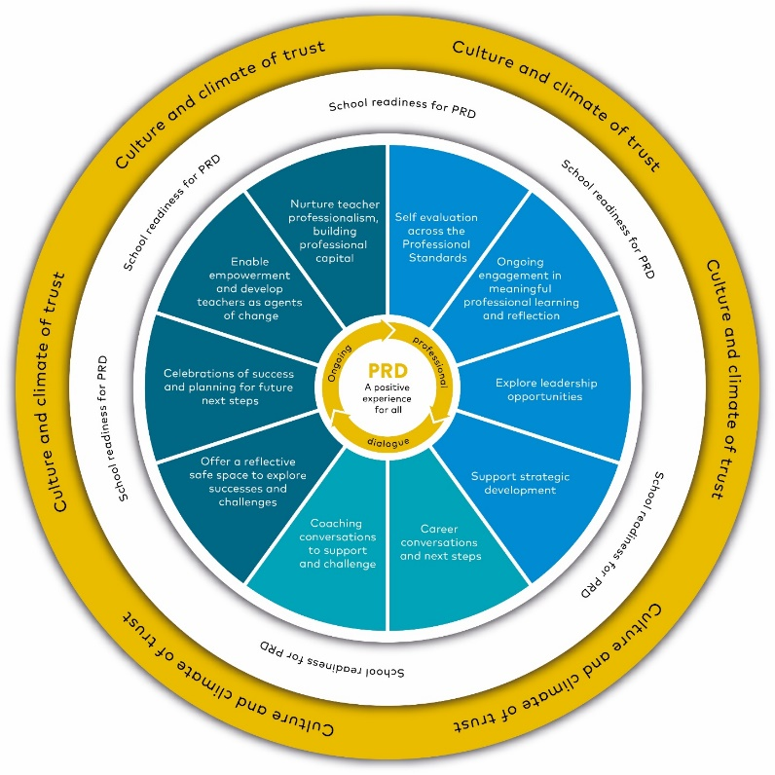
2. PRINCIPLES
2.1 PRD will be most effective when set within a culture of professional trust and positive relationships. Trust and respect are the foundations of effective PRD. High-quality PRD empowers teachers, whether they are reviewers or reviewees, to be leaders ‘of and for’ learning. The following principles apply:
- It is a high-quality experience, based on a high-quality coaching conversation with a reviewer, which provides support and challenge and is responsive to reviewees’ needs.
- All participants have a shared understanding of its purpose.
- Arrangements are simple with minimal bureaucracy, and allocated time in Working Time Agreements.
- It is integrated and appropriately timetabled into the normal life and management of the school and results in minimum disruption for pupils.
- It balances personal development priorities with the effective achievement of the establishment’s strategic improvement priorities, nurturing teacher professionalism and building professional capital.
- It offers an opportunity for recognising good performance and makes clear to teachers they are valued and appreciated.
- It encourages reviewees to reflect on their good practice and to share this with colleagues.
- It encourages reviewees to take a professional responsibility to lead their own improvement through self-evaluation.
- It enhances empowerment and develops teachers as agents of change.
- It explores leadership opportunities and includes career conversations and agreed next steps.
- The process should allow for ongoing professional learning conversations between reviewee and reviewer to discuss ongoing learning experiences.
- The process should be effectively evaluated.

2.2 The PRD process should be regarded as a professional entitlement as well as being a condition of service. Annually, every reviewee should discuss and agree their individual professional learning plans with their reviewer and maintain a personal professional learning record throughout the year. The PRD process is designed to give all staff registered with GTCS opportunities to:
- discuss progress and professional learning with a reviewer and receive appropriate feedback.
- engage in a process of reflection and self-evaluation against the appropriate GTCS Standards for the post held.
- review and evaluate progress towards previously agreed targets and professional development activities.
- agree next steps, including a professional learning plan for the next year.

3. SCHEME FOR PROFESSIONAL REVIEW AND DEVELOPMENT
3.1 Identification of Reviewers
3.1.1 For Heads of Establishments the review procedures will be carried out, in the case of Secondary HTs, by the Head of Education & Chief Education Officer, and the Cluster QIO/QIM in the case of Primary HTs.
3.1.2 All staff members, other than a Head of Establishment, will have a designated reviewer within his/her own establishment or service. Normally this will be the line manager. Identification of the reviewer will be a matter for discussion and negotiation at establishment level. Care should be taken not to overload any reviewer before commencing the review process.
3.1.3 Some members of staff are deployed in more than one department or may have a remit in addition to a class teaching responsibility. Each area of responsibility will be considered in the review process. However, only one reviewer will be responsible for conducting the review. In such situations the designated reviewer would require to consult other promoted members of staff familiar with the work of the reviewee. The choice of reviewer may depend, for example, on the relative proportions of time spent on particular duties by the reviewee.
3.1.4 Where members of staff work in more than one establishment, the reviewer should consult with all the establishments concerned. In the case of such staff the designated reviewer would normally be the line manager within the base school.
3.1.5 Where members of staff, including supply teachers, have worked in more than one establishment over the course of a year, the reviewer will normally be the line manager in the establishment where the reviewee is based at the time that the annual PRD meeting is due. There can be exceptions; where a supply teacher has spent most of the previous year working in a different establishment, they may prefer their PRD meeting to be with a line manager from that setting. The onus in that situation is on the reviewee to contact the line manager in the previous establishment to arrange a PRD meeting. Where a supply teacher is not working at the time their PRD is due, they should contact the Head of Establishment or CLPL coordinator of the last establishment they worked in to arrange a PRD meeting.
3.1.6 On a rare occasion there may be good reasons why the reviewee may request that the reviewer be someone other than the person designated. In such situations, and where agreed, the Head of Establishment will plan for the review to be carried out by an alternative manager.
3.1.7 Probationary teachers are not included in staff review procedures as their monitoring arrangements are in accordance with the national Teacher Induction Scheme.

3.2 Training for Reviewers and Reviewees
3.2.1 All reviewers must be familiar with the roles and responsibilities in PRD and should undertake PRD training and any subsequent updates. Annual training will be arranged and provided by the QIO/QIM responsible for Professional Learning.
3.2.2 Every member of staff will receive appropriate training.
3.2.3 Training for both reviewees and reviewers will include acquiring knowledge and understanding of:
- Aberdeenshire LNCT Agreement: Aberdeenshire Council – Professional, Review & Development 2021
- Principles of Coaching.
- How to create and maintain a professional learning record and construct a professional learning plan.
- The Scheme of Professional Update.
- GTCS Standards.

3.3 Resolving Disagreements
If disagreement occurs between reviewee and reviewer, the following procedure should be used:
3.3.1 Further discussion should focus on the cause of the disagreement and any relevant documents should be made available. Should the matter not be satisfactorily resolved at this level, the line manager of the reviewer may be asked to assist in reaching agreement/consensus. If either party wishes they may be accompanied by a colleague during any meeting.
3.3.2 Should the reviewer be a Head of Establishment, the approach for support should be to the school’s Quality Improvement Officer. Where the reviewer is the Quality Improvement Officer, the approach for support should be to the area Quality Improvement Manager.
3.3.3 It should be noted that formal grievance procedures, in accordance with staff conditions of service, are not affected by any of the foregoing and always remain available for staff.
3.4. The Professional Learning Profile
3.4.1 It is the responsibility of all members of staff to maintain a professional learning profile to support Professional Update. The profile will have two components:
- a record of significant professional learning and personal development activities undertaken.
- a plan which will be agreed with the line manager at the review meeting. The plan should indicate targets and the development activities agreed by the reviewer and the reviewee to take account of agreed strengths and development needs and linked to appropriate GTCS Standards. Account should be taken of the reviewee’s progress against previously agreed targets and their proposals to address needs they have identified.

3.4.2 Staff registered with GTCS are required to maintain a professional learning record providing details of their career long professional learning experiences. The record should focus on experiences which have had significant impact, supported by reflective comments and / or appropriate evidence which briefly capture their impact. The record will be maintained and updated by the reviewee and is used to stimulate professional dialogue, and to assist in planning future CLPL at establishment and cluster level. Reviewers and reviewees should be mindful at all times of minimising the level of paperwork required.
3.4.3 An extensive range of experiences can contribute to teacher CLPL. These may include:
• activities related to achieving GTCS Standards. | • secondments | • teacher placements.
• attendance at training courses | • professional reading and research | • collaborative working.
• membership of school committees and working groups | • professional dialogue to share understanding of standards, pedagogy, assessment, and strategies for raising attainment | • Into Headship, In Headship and other leadership development programmes associated with the GTCS Standards for Leadership and Management.
• developing school, local authority and national policies | • practitioner enquiry / professional inquiry. | • working with families.
• sharing good practice with colleagues from other establishments | • mentoring/supporting colleagues. | • SQA related activities.
• co-operative teaching | • curriculum planning and development. | • appropriate professional Trade Union activities.
• lesson observation and associated professional dialogue | • management and leadership development opportunities. | • any other activity agreed as part of the PRD process.

The above list is intended to be illustrative rather than exhaustive.

3.5 Time for Career Long Professional Learning
3.5.1 In addition to participating in professional learning activities during the 35-hour working week, all staff have a contractual responsibility to undertake a maximum of 35 hours of Career Long Professional Learning per annum.

4. MANAGING THE PRD PROCESS
4.1 At Head of Establishment level the Head of Education and Quality Improvement Officer team are responsible for ensuring implementation of the scheme. Below this level the Head of Establishment is responsible for ensuring the implementation of this scheme.
4.2 Heads of Establishment may wish to delegate the day-to-day management and co-ordination of professional learning activities to the Professional Learning Coordinator who should normally be a promoted member of staff.
4.3 The responsibility of the Professional Learning Coordinator should include:
• attending authority co-ordinator meetings.
• promoting a positive attitude towards PRD and encouraging staff in the process of self-evaluation and reflection regarding personal and professional needs.
• identifying, quantifying, and progressing professional learning priorities arising from the establishment’s improvement plan and individual professional learning plan.
• promoting the authority’s calendar of professional learning opportunities and in-service activities.
• liaising with reviewers and advising on appropriate staff development activities.
• co-ordinating the establishment procedures for PRD and professional learning undertaken by staff.
4.4 It is important to stress that the Professional Learning Coordinator does not have sole responsibility for all matters relating to CLPL. Line Managers clearly have a role in relation to the teachers they manage, and a particular member of staff may have responsibility for induction and support for probationers. The Professional Learning Coordinator has the task of liaising with all such staff and ensuring that the establishment’s programme fulfils the needs of the establishment’s improvement plan and provides a range of opportunities for individual and collaborative professional learning activities.
4.5 Annual training for PL Co-ordinators will be arranged and provided by the QIO/QIM responsible for Professional Learning.

5. STAGES IN THE PRD PROCESS
5.1 Preparation for Successful Review
The importance of self-evaluation and reflection is emphasised throughout the PRD process. Reviewees should reflect upon the following aspects of their professional life:
• areas of professional practice which give greatest satisfaction.
• self-evaluation of progress against appropriate GTCS Standards.
• professional learning agreed at the previous review meeting, and how activities have had an impact on their professional practice.
• identifying and addressing professional learning needs in respect of their own practice and that of the establishment’s improvement priorities, and local and national priorities.
• career aspirations. The reviewee will complete and submit their professional learning record on My GTCS in advance of the review meeting.
It is important to note that all preparatory activity and completion of documentation should be costed within the 35-hour allocation.
5.2 The Review Meeting
With sound preparation, the review meeting should last no more than one hour. For Heads of Establishment a review meeting may last up to two hours. Review meetings are likely to be successful when:
• both reviewee and reviewer are familiar with the benefits and impact a high-quality PRD can have and understand the roles and responsibilities for all within the process.
• both reviewee and reviewer see it as a positive experience and have a professional relationship based on trust and respect.
• the agenda is agreed and self-evaluation across GTCS Professional Standards is shared in advance, enabling the reviewer to prepare relevant questions with a coaching approach of challenge and support.
• professional discussion focuses on the evidence-based impact of professional learning on the reviewee as well as on learners and the learning community.
• unconscious bias is a consideration, and the reviewee has complete confidence that the process will comply with Equalities legislation.
• the targets agreed will impact on career long professional learning and personal development of the reviewee and support the establishment improvement priorities.
An agreed agenda may include the following: -
• Recognition of strengths and review areas of professional practice identified by reviewee as giving the greatest satisfaction over the past year.
• Review the progress made in meeting targets agreed at the previous year’s review meeting and evaluate evidence from the professional learning record and any other appropriate sources.
• Review results of any self-evaluation and reflection, for example against the agreed sections of the appropriate GTCS Standard. Consider using the GTCS Coaching Wheels (www.gtcs.org.uk/professional-standards/self-evaluation/)
• Discuss the impact of professional learning activities undertaken.
• Identify and agree professional learning targets, based on strengths, and needs, considering possible career aspirations.
• Identify and agree outcomes and professional learning activities in the professional learning plan which will be undertaken for the following year. This will include the reviewee’s additional contractual maximum 35 hours CLPL.
• Comments from reviewee and reviewer on other any relevant matter(s). In a year of Professional Update, the professional learning record will be signed off to meet the requirements of the GTCS 5-year Professional Update cycle. This is done through the professional learning record sign-off page in MyGTCS. There may be circumstances which make completion of the Professional Update process within the designated timescale difficult.
These circumstances may include:
• career breaks.
• extended illness.
• maternity / paternity / adoption leave.
• occasional supply work.
If a registrant is unable to complete the process in the designated year, they will have the opportunity to request a deferral. They should make this request directly to Paul Rooke (Quality Improvement Manager) who will notify GTCS of their decision. Deferrals will normally be granted for one year.
There is a process to bring forward the year of Professional Update sign off in exceptional circumstances. Teachers who are planning, on retirement, to undertake supply work may choose to complete the Professional Update sign-off process in their last year of teaching prior to retirement to maintain fully registered status for a further five years. It is good practice to remind teachers who are planning to retire of this option. Please note that retired teachers who return to supply work are required to engage in the PRD process.
Following the meeting the reviewee will complete the professional learning record on MyGTCS.
During the above process on MyGTCS, the reviewee should check and update their registration details with GTCS. It is vital that this is done every year.
5.3 Implementing and Monitoring the Professional Learning Plan
It is the responsibility of the reviewee to implement the professional learning plan. However, it is important that regular professional dialogue between reviewee and reviewer is maintained to ensure progress towards meeting the agreed outcomes and to support the professional learning activities.
5.4 The Professional Learning Record
The reviewee has a responsibility to update and maintain their professional learning record.
5.5 The Professional Learning Portfolio
This is a personal portfolio containing documents relating to professional and career development. There is no requirement for staff registered with GTCS to maintain a professional learning portfolio, however, it is recognised as good practice, regardless of their experience or aspirations. It can offer a systematic method of recording professional analysis and development throughout a teacher's career. The professional learning portfolio would remain personal to the individual teacher but could be used to:
• present an analysis of personal and professional development.
• present illustrations of current skills and abilities.
• provide additional support in preparing for PRD.
• provide a basis for discussion with key colleagues.
• plan future professional learning
• self-evaluate professional competence; and
• assist in recording activities which may lead to accreditation.
The contents of a professional learning portfolio will vary but might include:
• personal details.
• professional qualifications.
• employment history.
• job descriptions of current and previous posts.
• a professional learning profile.
• an analysis of professional experiences.
• self-evaluation of professional competence (using, for example, aspects of the appropriate GTCS Standard).
• reflective commentaries on professional learning activities undertaken.
• a personal development plans.
• certificates.
• a CV.
6. MONITORING AND EVALUATING THE PROCESS
6.1 At local level, it is the responsibility of the Head of Establishment to monitor and evaluate the effectiveness of the establishment’s PRD arrangements in enhancing the quality of learning experiences and the impact on attainment and achievement. Evaluation should also include how far identified professional learning needs have been met.
6.2 At authority level, the Quality Improvement Manager with responsibility for PRD has a monitoring and evaluation role in relation to the PRD process and related CLPL.
6.3 It should be noted that these activities will not impinge on the confidential nature of the process between reviewee and reviewer.
7. LNCT MONITORING
These agreed procedures will be reviewed by the LNCT no later than January 2023.

